Virtual Network & Subnet Design

The Virtual Network with Address space 10.0.0.0/16 contains 2 segmented subnets (10.0.1.0/24, 10.0.2.0/24). Each subnet is associated with Network Security Group.

Virtual Network (vnet-labs)

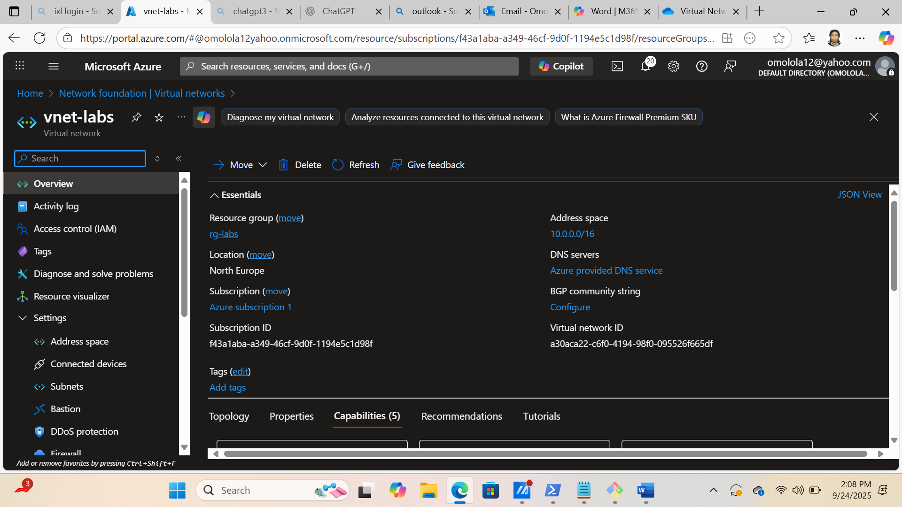

Subnet 1(subnet-web-labs)

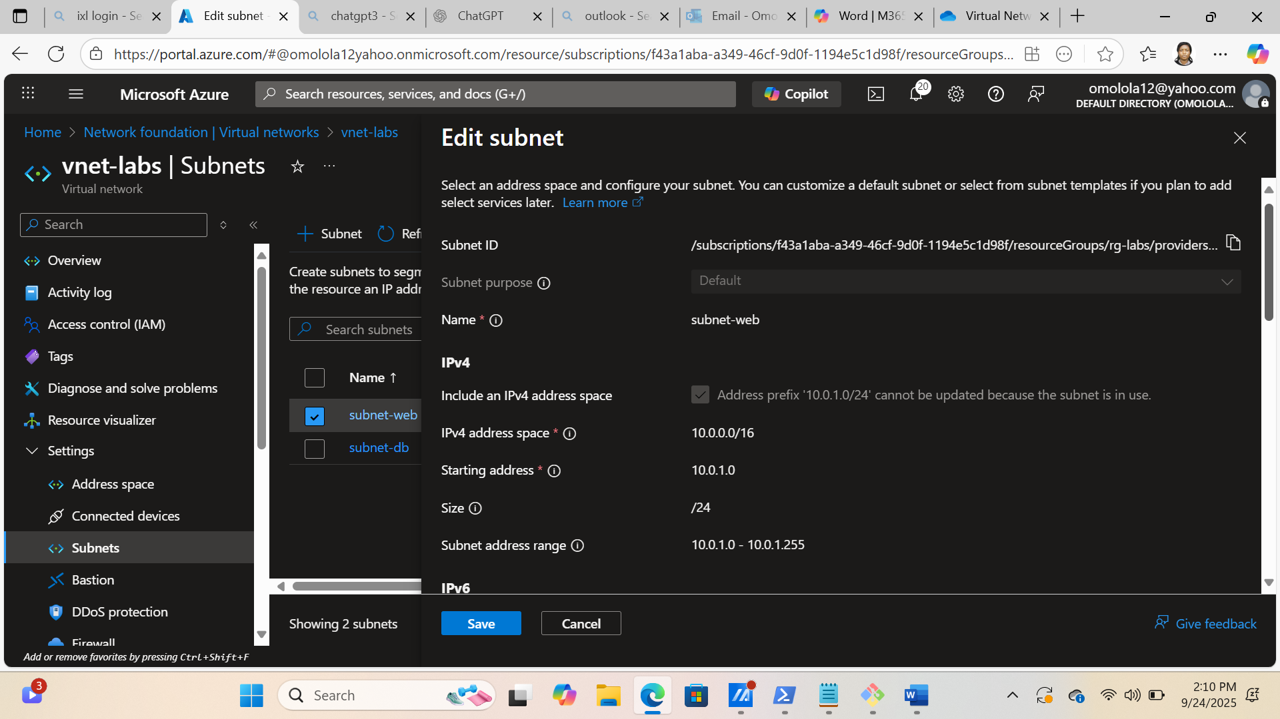

Subnet 2 (subnet-db-labs)

